Final Project Milestone Five

Model Optimization

Michael Surdek
Southern New Hampshire University
DAT 640: Predictive Analytics
Professor Tom Woolman
February 27, 2022
Evaluation
There numerous metrics available to measure the effectiveness of a predictive model, including accuracy, sensitivity, specificity, recall, precision, log loss, and area under curve. These “will allow us to understand what to expect when we use the model to score new observations.” (Williams, 2021) Evaluation can help to decide between competing models and to improve an individual model.
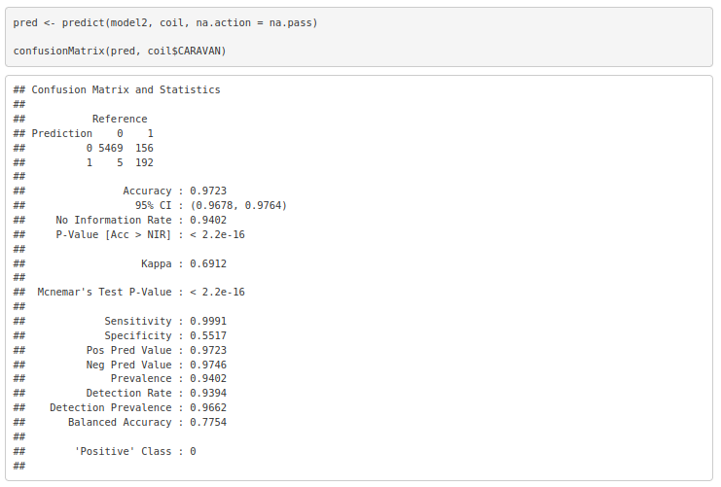
The confusion matrix of the gradient boosting machine model “shows the number of correct and incorrect predictions made by the classification model compared to the actual outcomes (target value) in the data.” (Sayad, 2017) The simple counts from the confusion matrix can be used to calculate the accuracy, sensitivity, specificity, positive predictive value, and negative predictive value. For example, the specificity is the proportion of true positives out of all positive predictions. For this model, it is 192 / 156 + 192, or 55%.

Additional evaluation metrics can be generated from the multiClassSummary function of the caret package. For example, the log loss, which accounts for the confidence of each prediction, is 0.075, and the Kappa statistic, which “represents the extent to which the data collected in the study are correct representations of the variables measured,” (McHugh, 2012) is 0.691.
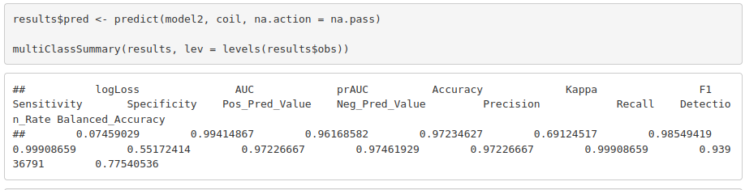
Finally, another key evaluation metric is the area under the curve, which is derived from an ROC chart that plots the true and false positive rate. The AUC of the gradient boosting machine model is 0.74. AUC serves as useful measure to compare the performance of multiple models. The curves can be included and compared on the same ROC chart. This may show that one model is best across the board, or even that one model performs better at a lower or higher false positive rate than others, which may be preferable based on the objective of the model.
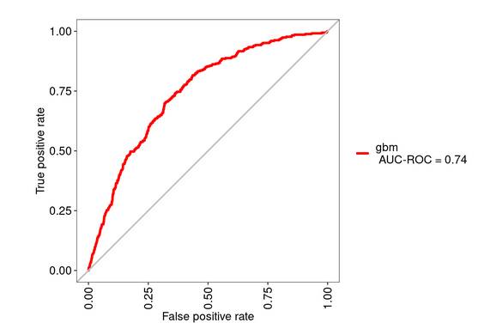
Scoring
For The Insurance Company to make use of this predictive model, they will have to implement a scoring engine that applies the model to new data and uses the predictions to guide their strategy. In this situation, TIC is hoping to email its prospects with a caravan insurance promotion, but to avoid those who already hold that policy. A scoring engine could be implemented by feeding information about potential prospects, which must match the contents of the training data, into the gbm model. The results of the scoring engine would be a yes or no output that predicts caravan insurance ownership. The prospects that the model predicts “yes” could then be removed from the promotional mailing list.
The expected results of the scoring engine can be estimated from some of the evaluation metrics above. For example, based on the confusion matrix, of the 5473 observations where the customer did not already hold caravan insurance, only 5 were not predicted as such. On the other hand, 192 of the 348 observations where the customer did already hold caravan insurance were predicted correctly. The model accurately predicts 99.9% of non-caravan insurance owners and 55.2% of caravan insurance owners, for an overall accuracy rate of 97.2%. If The Insurance Company used this model to advise their marketing strategy, they could then expect to successfully eliminate 55% of current caravan policy holders, at the cost of missing less than one in a thousand potential prospects.
References:

McHugh, Mary. 2012. Interrater reliability: the kappa statistic. Biochem Med (Zagreb). Retrieved from https://pubmed.ncbi.nlm.nih.gov/23092060/

Sayad, Saed. 2017. Model Evaluation – Classification. Saedsayad.com. Retrieved from
https://web.archive.org/web/20170107084843/http://saedsayad.com/model_
evaluation_c.htm

Williams, Graham. 2011. Data Mining with Rattle and R : The Art of Excavating Data for Knowledge Discovery. Springer New York. Retrieved from http://ebookcentral.proquest.com/lib/snhu- ebooks/detail.action?docID=770229

